Careers Education, Information, Advice and Guidance Policy

 | Policy implemented: | March 2023
 | Last reviewed: | na
 | Next review due: | March 2025
EQUALITY AND DIVERSITY STATEMENT

The Salutem Group is committed to the fair treatment of all in line with the Equality Act 2010. An equality impact assessment has been completed on this policy to ensure that it can be implemented consistently regardless of any such factors, and all will be treated with dignity and respect.

Contents
- Contents

- School Vision

- Policy Scope

- Aims

- School Responsibilities

- Governor Responsibilities

- Provider Access

- Monitoring, Evaluation and Review

- Useful Links

School Vision
Ingfield Manor School is committed to providing a broad and balanced holistic and multi-sensory
curriculum which meets the diverse needs of all our learners.

At Ingfield Manor School we work with consideration, commitment and co-operation to ensure our school community will develop the capacity to enjoy life and succeed.

Whilst at Ingfield Manor School, students are taught the skills and attitudes required to enable them to become as independent as they can be and to prepare for adulthood. Our aim is for our students to have an enriched and stimulating curriculum which provides them with opportunities to reach their full potential regardless of gender, race, learning disability or physical disability.

- Policy Scope
3.1 This policy covers Careers Education, Information, Advice and Guidance for students within Ingfield Manor School.

3.2 The policy has been reviewed in line with the DfE guidance document ‘Careers guidance and access for education and training providers – Statutory guidance for governing bodies, school leaders and school staff. (DfE, January 2023)

3.3 This policy accepts the 8 Gatsby Charitable Foundation’s benchmarks as set out in the DfE guidance. They can be seen in Appendix 1 of this policy

3.4 This policy covers the legal duty of schools to ensure that a range of education and training providers can access students in Year 7 to Year 11 for the purpose of informing them about approved technical education qualifications or apprenticeships.

3.5 This policy refers to events and opportunities across our secondary and 6th form departments, which will be adapted to meet the needs of all children and young people in these years.

3.6 All teaching staff working at Ingfield Manor School within our secondary and 6th form departments are expected to be aware of this policy and the importance of Careers Education, Information, Advice and Guidance (CEIAG) in the education of students; CEIAG is not the sole responsibility of the careers leader.

  - It is important that students leave school aware of themselves as individuals, aware of the
opportunities available to them and able to make some decisions about their own life. They should be prepared for the transition from full time education to the world beyond. It is to these aspects of personal and social development that this policy will contribute.

- Aims
It is our intention that our careers education, information, advice and guidance policy (CEIAG) will:
- Develop the skills, attributes and qualities of our students, which will prepare them for adulthood and the transition to life after Ingfield Manor.
- Support our students to make informed decisions about their future, which are appropriate for them.
- Enable our students to make good use of information, advice and guidance.
- Develop our students’ self-knowledge and enable them to use this when thinking about and making course and other choices.
- Extend our students’ understanding of opportunities in learning and work.
- Provide our students with well-rounded experiences.
- Develop our students’ personal characteristics such as social skills, communication, independence, and resilience.
- Inspire and motivate our students to develop themselves as individuals and live as independently as is possible.
- Help students build skills that will be transferable and adaptable to different environments.
- Will meet the requirements of the Gatsby Benchmarks (see appendix 1) by:
  - Ensuring that all students at the school receive a stable careers programme, appropriate to their abilities and needs.
  - Enabling all students to learn from information provided by the career and labour market when they are able.
  - Ensuring our CEIAG programme is personalized and will address the needs of each student.
  - Linking the curriculum learning to careers learning.
  - Providing students with a series of encounters with employers and employees, as appropriate to the needs of the students.
  - Providing students with experiences of workplace(s).
  - Ensuring that students have a series of encounters with further education.
  - Providing each student, where it is considered appropriate, with the opportunity to receive personal guidance.

School Responsibilities
5.1 The school has a series of statutory duties:

- Have a named Careers Leader in place who is responsible and accountable for the delivery of the school’s careers programme,
- All students must receive independent careers advice in Years 7 to 11, unless it is agreed that this is not appropriate due to the students’ SEND needs.
- This careers advice must be represented in an impartial manner, showing no bias towards a particular institution, education or work option.
- This advice must cover a range of education or training options.
- This guidance must be in the best interests of the student.
- There must be an opportunity for education and training providers to access students in Year 7 – Year 11 to inform them about the range of opportunities available to them as they reach the end of year 11 and year 14. See section 7 of this policy and our Provider Access Policy Statement.
- The school must have a clear policy setting out the manner in which providers will be given access to students. See section 7 and our Provider Access Policy Statement. This policy and these arrangements must be published on the school website.

5.2 The school will base its careers provision around the Gatsby Benchmarks. A summary of these can be seen in appendix 1, and they cross reference with the objectives of this policy (section 3).

5.3 Ingfield believes that good CEIAG connects learning to the future. It motivates young people by giving them the skills and knowledge to be as independent as possible and, when appropriate, a clearer idea of the routes to jobs and careers that they will find engaging and rewarding. Good CEIAG widens students’ horizons, challenges stereotypes and raises aspirations. It provides students with the knowledge and skills necessary to make successful transitions to the next stage of their life. This supports social mobility by improving opportunities for all young people, especially those from disadvantaged backgrounds and those with special educational needs and disabilities.

5.4 The school will continuously monitor its CEIAG offer and seek further improvement. This will be done by the personnel involved in the design and delivery of the programme as well as by external stakeholders who assess the work of the school (e.g. School Improvement Partner or Ofsted)

Governor Responsibilities
6.1 The governance of Ingfield Manor School, including Woodview, is through our proprietors, Salutem Care and Education. The Divisional Director will ensure that the school has a clear policy on Careers Education, Information and Guidance (CEIAG) and that this is clearly communicated to all stakeholders. They will ensure that this policy is:

- based on the eight Gatsby Benchmarks

- meeting the school’s legal requirements

6.2 The Divisional Director will ensure that arrangements are in place to allow a range of educational and training providers to access pupils in Years 7 – 11.

6.3 Our local governing body may contribute in an advisory capacity and there may be a member of the governing body who takes a strategic interest in CEIAG and encourages employer engagement, although the responsibility for this oversight is with Salutem’s Divisional Director for Education.

7 Provider Access
Introduction - This section of the policy sets out the school’s arrangements for managing the access of providers to pupils at the school for the purpose of giving them information about the provider’s education or training offer. This complies with the school’s legal obligations under Section 42B of the Education Act 1997 and the Skills and Post-16 Act 2022.

7.2 All pupils in years 8-13 are entitled:

- to find out about the full range of education and training options available at each transition point
- to hear from a range of appropriate local providers about the opportunities they offer, including technical education and apprenticeships – through assemblies, visits, group discussions and attendance at local careers fairs
- to understand how to make applications for the full range of academic and technical courses.

7.3 Appendix 2 shows the way in which education and training providers should get in touch with the school in order to gain access to pupils and/or parents to inform them about further opportunities

7.4 The school will then work with providers in order to identify the most effective opportunity for them to share information about education and training opportunities
8 Monitoring, Evaluation and Review

The Principal will ensure that:

- the work of the Careers Leader and CEIAG events are supported and monitored

- a member of the Senior Leadership Team has an overview of CEIAG work and reports

regularly back to the team

The effectiveness of this policy will be measured in a variety of ways:

- feedback from stakeholders through annual reviews, parents’ mornings, and student and

parent surveys

- feedback from external visitors to the school such as Salutem Quality Team, Divisional

Director, local authorities, and Ofsted

- the number of students who are not in education, employment or training (NEET) in October

having left the school in the previous summer. It is our intention that 100% of our students

will move to another education provision, unless the local authority decides that their EHCP

needs to cease. In this situation, the school will work with the student’s social worker and

parents to try to ensure that they have access to appropriate activities to keep them

engaged and continue to develop their independence skills.

The divisional director will review this policy every three years.

9 Useful Links

There are a large number of web sites available that can be shared with our students/ parents where appropriate. Below is a selection of those that may be of benefit:
- Coast 2 Capital – Your Futures

This Information Hub area gives you lots of useful information about where you can study after school. It will also give you information about local mainstream colleges with SEND provision, as well as specialist colleges. This area also offers support and information about the local offer, training providers, supported internships, Disability Confident employers and other useful information about gaining employment in the future. Finally, there is a section of career resources to help you prepare for your future and a video resource directory.
- www.prospects.ac.uk/job-profiles
Prospects offer a large amount of information with regards to various career options. This site enables you to see various careers giving details of each individual career, including responsibilities, salary, working hours, what to expect, qualifications required, skills required, work experience, prospective employers, professional development and career prospects.
- www.nationalcareersservice.direct.gov.uk
This has a variety of information including a job profiles section which has detailed information on a variety of careers/work areas.
- www.barclayslifeskills.com
This has a variety of information with regard to planning your future including advice on job hunting and interview skills.
- www.stepintothenhs.nhs.uk/
This site is aimed at 14-19 year olds with activities and information that promote and inform young people of the career opportunities with the NHS.
- www.goconstruct.org
This site will enable you to explore all areas of construction, using blogs, videos and quizzes.
- www.gov.uk/apprenticeships-guide
This site has a variety of information about apprenticeships and contains a large number of actual vacancies. Young people can register on the site and be notified of suitable opportunities. For many companies this is the main way to make apprenticeship applications.
- www.gov.uk/government/publications/a-parents-guide-to-apprenticeships
A useful parents guide to apprenticeships, explaining the benefits and progression routes of apprenticeships.
- www.indeed.co.uk
A general job web site but some companies advertise apprenticeships on here.
- www.getmyfirstjob.co.uk
This site contains some apprenticeship vacancies and general information on job search/applications for young people.
- www.notgoingtouni.co.uk
This site has a variety of useful information for school leavers and is especially aimed at young people not wanting to go into Higher Education
- www.brightknowledge.org
Bright Knowledge is a useful guide to careers, education and student life. It aims to help you with what you want to achieve and how you can get there.
- www.do-it.org
- Information on volunteering
- www.ncsyes.co.uk
- The National Citizen Service offer a great programme of activities for students aged 15 – 17 years old. The programme is a great personal development, confidence building and something great to put on your CV.
- www.volunteeringmatters.org.uk/want-to-volunteer
- This site has lots of information with regards to voluntary work and the opportunity to search for programmes in your local area.

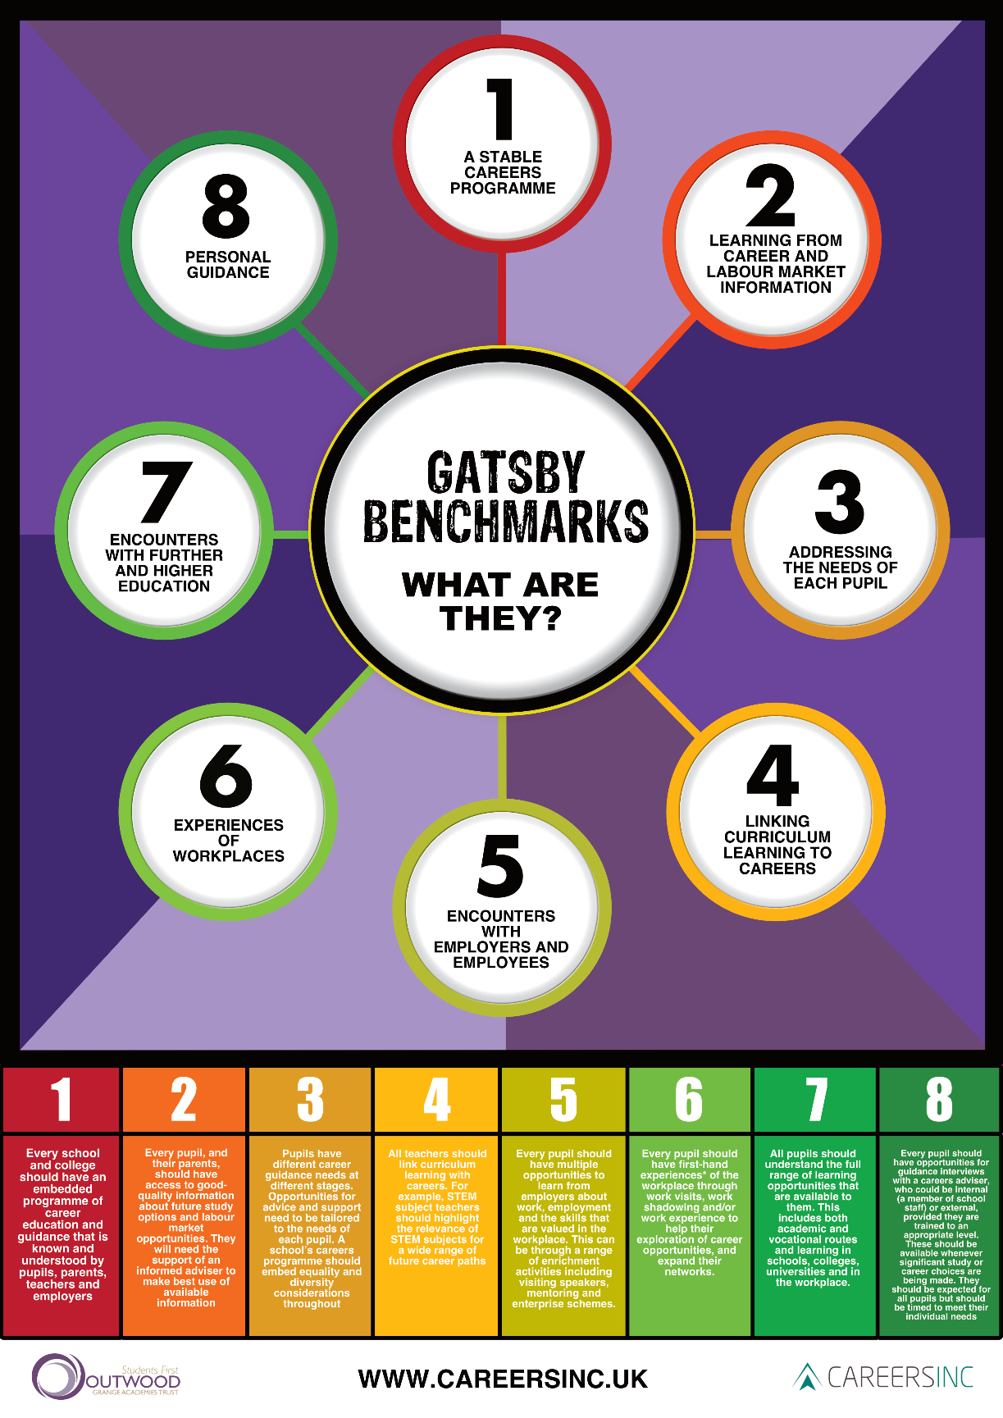
Appendix 1

Appendix 2

Provider Access Policy Statement

Approved by: | Nicola Dodds | Date: 11.02.2021
Last reviewed on: | 03.04.2023
Next review due by: | 03.04.2024

Contents
1. Aims 3
2. Statutory requirements 3
3. Student entitlement 3
4. Management of provider access requests 3
5. Links to other policies 5
6. Monitoring arrangements 5

1. Aims
This policy statement aims to set out Ingfield Manor’s arrangements for managing the access of education and training providers to students for the purpose of giving them information about their offer. It sets out:
- Procedures in relation to requests for access
- The grounds for granting and refusing requests for access
- Details of premises or facilities to be provided to a person who is given access

2. Statutory requirements
Schools are required to ensure that there is an opportunity for a range of education and training providers to access students in years 8 to 14 for the purposes of informing them about approved technical education, qualifications or apprenticeships.
Schools must also have a policy statement that outlines the circumstances in which education and training providers will be given access to these students.
This is outlined in section 42B of the Education Act 1997 and the Skills and Post-16 Act 2022
This policy shows how Ingfield Manor complies with these requirements.

3. Student entitlement
All students in years 8 to 14 at Ingfield Manor are entitled to:
- 6 encounters during these years with further education and specialist education providers to find out what education and training opportunities are available to them, as part of our careers programme. However, due to the SEND of our students, there may not be six encounters. Ingfield Manor will do all it can to provide as many meaningful encounters as possible.
- Hear from a range of local providers about the opportunities they offer, including technical education and apprenticeships
- Understand how to make applications for the full range of academic and technical courses
- Due to the SEND of the students at Ingfield Manor School, we recognise that some students may not be ready for this information from year 8. Therefore, we will liaise with parents and other key stakeholders to consider the most appropriate way to ensure students receive appropriate information in a timely manner.

4. Management of provider access requests
4.1 Procedure
A provider wishing to request access to students for the purpose of giving them information about their offer should contact Annette Smith, Careers Leader and Head of Education.
Telephone: 01403 782294
Email: annette.smith@ambitoeducation.co.uk
4.2 Opportunities for access
We recognise that due to the number of students looking at the next stage in their education we need to be flexible regarding opportunities for further education and specialist education providers to access our students. Therefore we are open to arranging small scale events to suit these providers availability so they are able to come into school to speak to students and/or their parents/carers.
We recognise that, due to the number of students and nature of their needs, providers may not be able to visit the school. Therefore, we will make every effort to take our students to visit appropriate providers within a commutable distance from Ingfield Manor.
4.3 Granting and refusing access
Access to students will be granted as long as informed consent is in place from student and parents/carers as applicable..
4.4 Safeguarding
Our safeguarding/child protection policy outlines the school’s procedure for checking the identity and suitability of visitors.Regular visitors that may work independently with our students will be captured on our single central register.
Education and training providers will be expected to adhere to this policy.
4.5 Premises and facilities
- We will make available suitable facilities to enable providers to access students, such as hall, classroom, office. Also, we will make available specialist equipment to enable students to communicate, as well as IT equipment for presentations etc.
- The facilities available for each access request will be dealt with on an individual basis, in consultation with the provider.
- Providers will be able to leave prospectuses or other material for students and their parents’ information. Ingfield Manor will arrange for documents to be sent home, if appropriate.

5. Links to other policies
- Safeguarding/child protection policy
- Careers policy
- Curriculum statements

6. Monitoring arrangements
The school’s arrangements for managing the access of education and training providers to students are monitored by Annette Smith, Head of Education and Careers Leader.
This policy will be reviewed annually.

