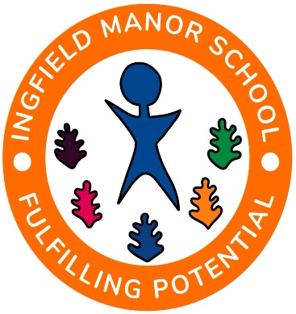

OPEN MORNING
WOODVIEW SECONDARY PROVISION PROSPECTIVE SEPTEMBER 2025 YEAR 7 STUDENTS
Our Woodview provision supports secondary aged young people with speech, language and communication difficulties.

TUESDAY 21st May 2024 – 10.30am – 11.30am

At Ingfield Manor School, Ingfield Manor Drive, Five Oaks, West Sussex RH14 9AX
www.ingfieldmanorschool.co.uk

- A brief introduction to Woodview
- Tour of the grounds

Should you wish to attend please contact Gayle Calderwood on 01403 782294 or gayle.calderwood@ambitoeducation.co.uk

